PEERS Deployment Guide
——————————————————————————————————————————

Part 1: Preparing a model for deployment

Your model should be uploaded to Huggingface. Before it can be deployed to Huggingface, it needs a handler.py.

- First you will need to install Git LFS.

Follow the instructions here to do so:
https://docs.github.com/en/repositories/working-with-files/managing-large-files/installing-git-large-file-storage

- Check out your model from Huggingface to your local environment using git:

git clone https://huggingface.co/peers-ai/<model_name>

3. Now add a handler.py to the local directory.

Here is a below sample:

<<<

# handler.py — Fixed for Qwen3-30B-A3B LoRA (no hangs, 4-bit, direct generate)

import json
import logging
from typing import Any, Dict, List, Optional

import torch
from transformers import (
AutoTokenizer,
AutoModelForCausalLM,
StoppingCriteria,
StoppingCriteriaList,
BitsAndBytesConfig,
)

logging.basicConfig(level=logging.INFO)
log = logging.getLogger(__name__)

class StopOnStringsLoose(StoppingCriteria):
def __init__(self, tokenizer, stop_strings: List[str]):
self.stop_ids = [tokenizer.encode(s, add_special_tokens=False) for s in (stop_strings or []) if s]

def __call__(self, input_ids: torch.LongTensor, scores: torch.FloatTensor, **kwargs) -> bool:
seq = input_ids[0].tolist()
for ids in self.stop_ids:
L = len(ids)
if L and len(seq) >= L and seq[-L:] == ids:
return True
return False

class EndpointHandler:
def __init__(self, model_dir: str):
log.info("Loading tokenizer/model (4-bit)...")
torch_dtype = torch.bfloat16
quant_config = BitsAndBytesConfig(
load_in_4bit=True,
bnb_4bit_quant_type="nf4",
bnb_4bit_compute_dtype=torch_dtype,
bnb_4bit_use_double_quant=True,
)

self.tokenizer = AutoTokenizer.from_pretrained(model_dir, trust_remote_code=True)
self.model = AutoModelForCausalLM.from_pretrained(
model_dir,
torch_dtype=torch_dtype,
device_map="auto",
quantization_config=quant_config,
trust_remote_code=True,
)

# Fix EOS/PAD
if self.tokenizer.pad_token is None:
self.tokenizer.pad_token = self.tokenizer.eos_token
self.model.config.pad_token_id = self.tokenizer.pad_token_id
self.model.config.eos_token_id = self.tokenizer.eos_token_id

log.info("Model ready.")

def _build_prompt(self, data: Dict[str, Any]):
messages = data.get("messages") or [{"role": "user", "content": data.get("inputs", "")}]
# Esoteric instructions + /no_think
messages.insert(0, {"role": "system", "content": "Be concise. Answer in 1–2 paragraphs. No meta-text. /no_think"})
return self.tokenizer.apply_chat_template(messages, tokenize=False, add_generation_prompt=True)

def __call__(self, data: Dict[str, Any]) -> Dict[str, Any]:
params = data.get("parameters") or {}
max_new_tokens = int(params.get("max_new_tokens", 256))
temperature = float(params.get("temperature", 0.2)) # Low for esoteric focus
top_p = float(params.get("top_p", 0.6))
repetition_penalty = float(params.get("repetition_penalty", 1.5)) # High to avoid loops
stop_list = params.get("stop", []) or []
if isinstance(stop_list, str): stop_list = [stop_list]

prompt = self._build_prompt(data)
inputs = self.tokenizer(prompt, return_tensors="pt").to(self.model.device)

stopper = StoppingCriteriaList([StopOnStringsLoose(self.tokenizer, stop_list)])

log.info("Starting generation...")
with torch.no_grad():
try:
outputs = self.model.generate(
**inputs,
max_new_tokens=max_new_tokens,
do_sample=True,
temperature=temperature,
top_p=top_p,
repetition_penalty=repetition_penalty,
eos_token_id=self.tokenizer.eos_token_id,
pad_token_id=self.tokenizer.pad_token_id,
stopping_criteria=stopper,
)
text = self.tokenizer.decode(outputs[0][inputs["input_ids"].shape[-1]:], skip_special_tokens=True)
except Exception as e:
log.error(f"Generation failed: {e}")
text = "[Error: Generation failed]"
log.info("Generation complete.")

# Post-trim stops
for s in stop_list:
i = text.find(s)
if i != -1:
text = text[:i].strip()

torch.cuda.empty_cache()
return {"generated_text": text}

>>>

4. Commit your model back to Huggingface.

Part 2: Deploying on Huggingface

We deploy our models on Huggingface Endpoints. This guide will explain how to deploy a peer-ai model on HF Endpoints.
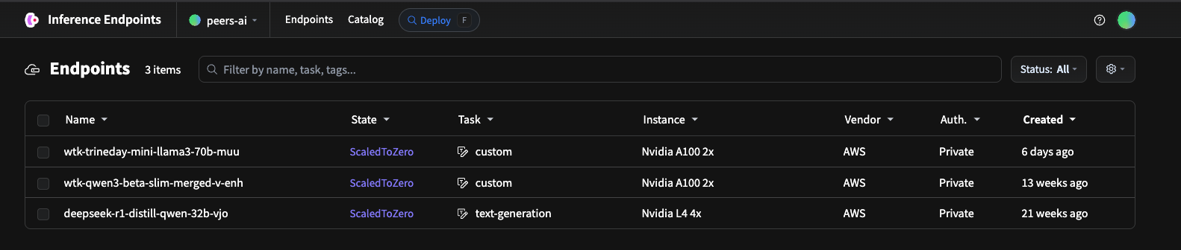
Another good guide is this one:
https://huggingface.co/blog/inference-endpoints-llm

The path to deployment is different whether you are using a public model or a private model on your account.

If you are deploying a private model, then you have to do so from within your Huggingface account page and not from Huggingface Endpoints.

Peers-ai huggingface account page:
https://huggingface.co/peers-ai/models

Since we assume we are dealing with our peers-ai models, we will show instructions how to deploy a private model

- From the peers-ai account page, choose the model you want to deploy and go to its page.

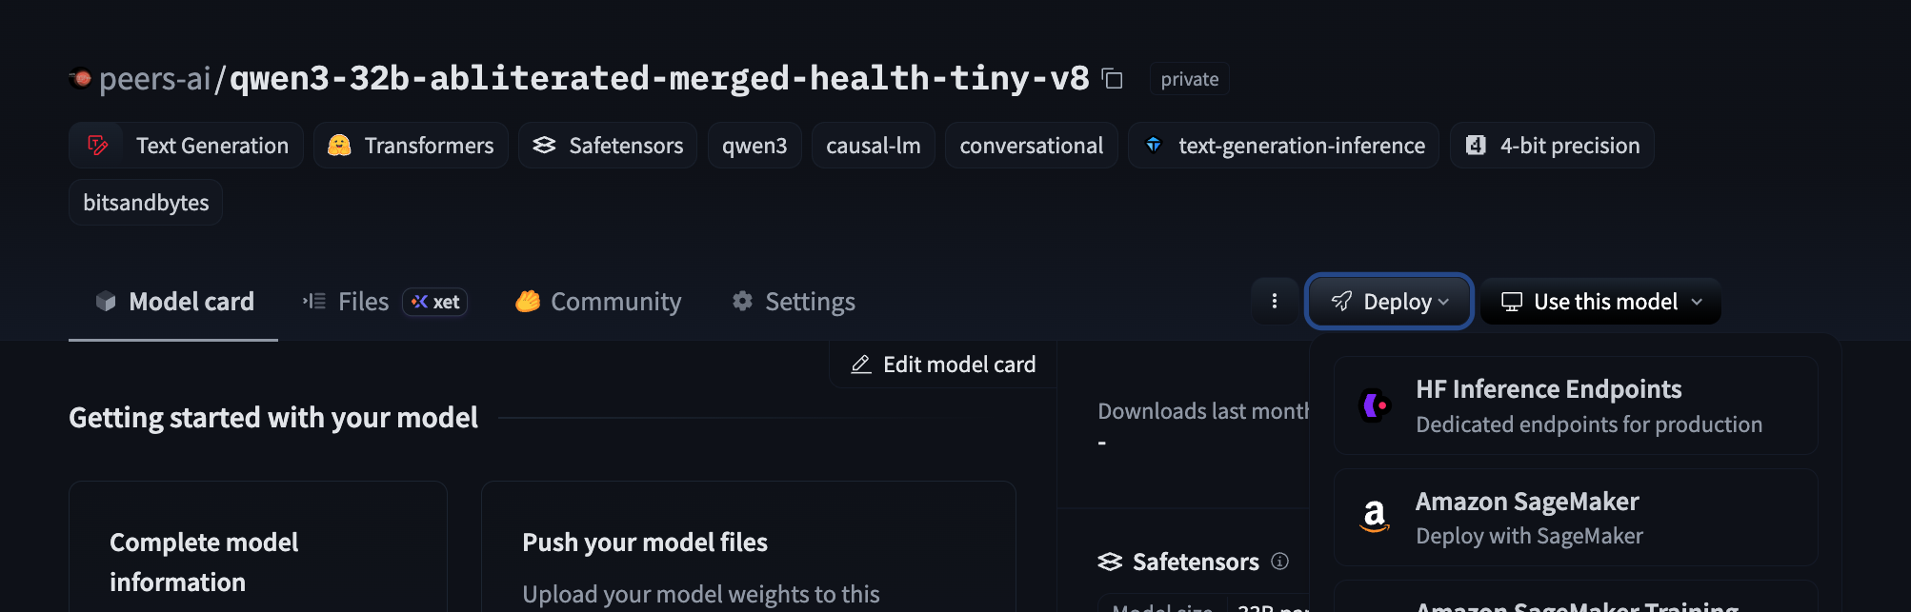
- Find the Deploy button on the model’s page and then choose “HF Inference Endpoints.”
The Deploy button should be on the middle-right. When you click, a sub-menu of options will appear. Click the option “HF Inference Endpoints.”

Note: there are cases when the “Deploy” button doesn’t appear at all. If this is the case, follow the below instructions.

This is a known issue and somewhat confusing. But the Deploy button will only appear for transformer models. See the link here for more info.
https://discuss.huggingface.co/t/deploy-button-not-showing-fine-tuned-llama-3-1/103630

You will need to add a README.md file to your model files and then add the following to the top:
---
library_name: transformers
tags:
- text-generation
- causal-lm
---

Add this change and commit it. Then you should see the Deploy button show up.

Part 3: Configuring the new instance on HF Endpoints

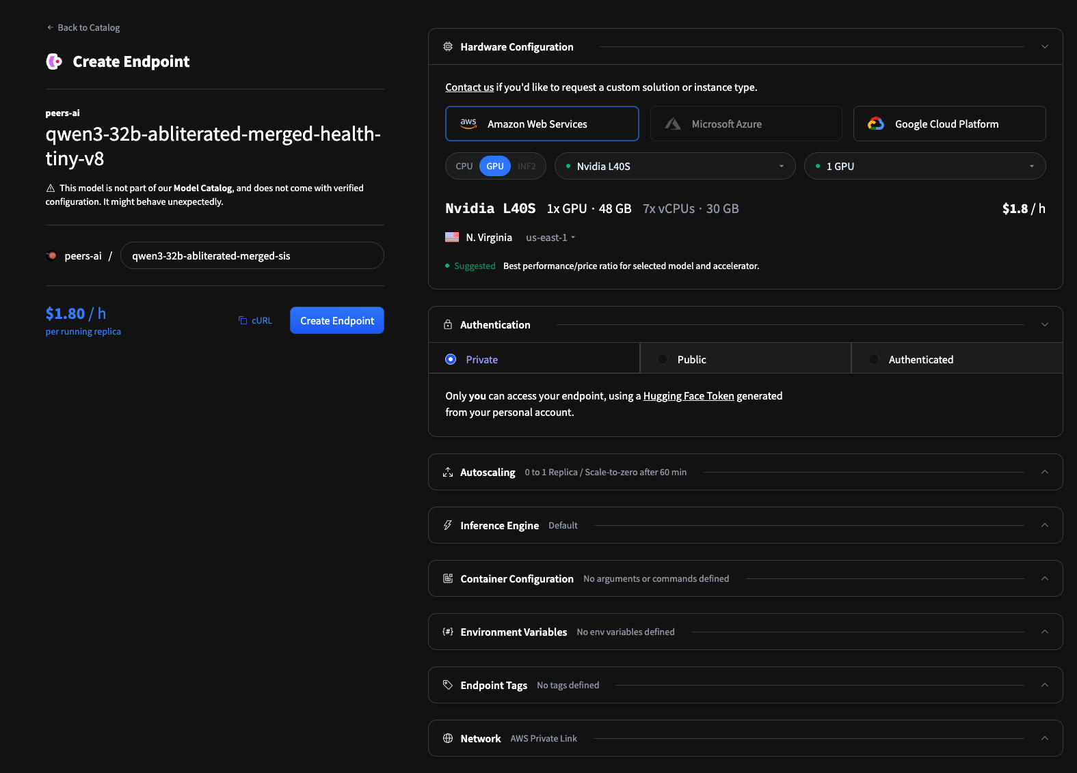
The Create Endpoint page will open up.
Regarding configuration:
- Under “Hardware Configuration” we have been using AWS by default though you can select whichever you feel. Then you will want to select GPU. Then a reasonable hardware default should be selected for you.
- Authentication should be “Private.”
- For Autoscaling, we can use min 0 and max 1. Autoscale to zero after either 30 min or 1 hour with no activity.
- Everything else can be kept at default.

Once you are ready, then click “Create Endpoint”.

Part 4: Managing the instance

Now the endpoint will be created. The dashboard will look like this.

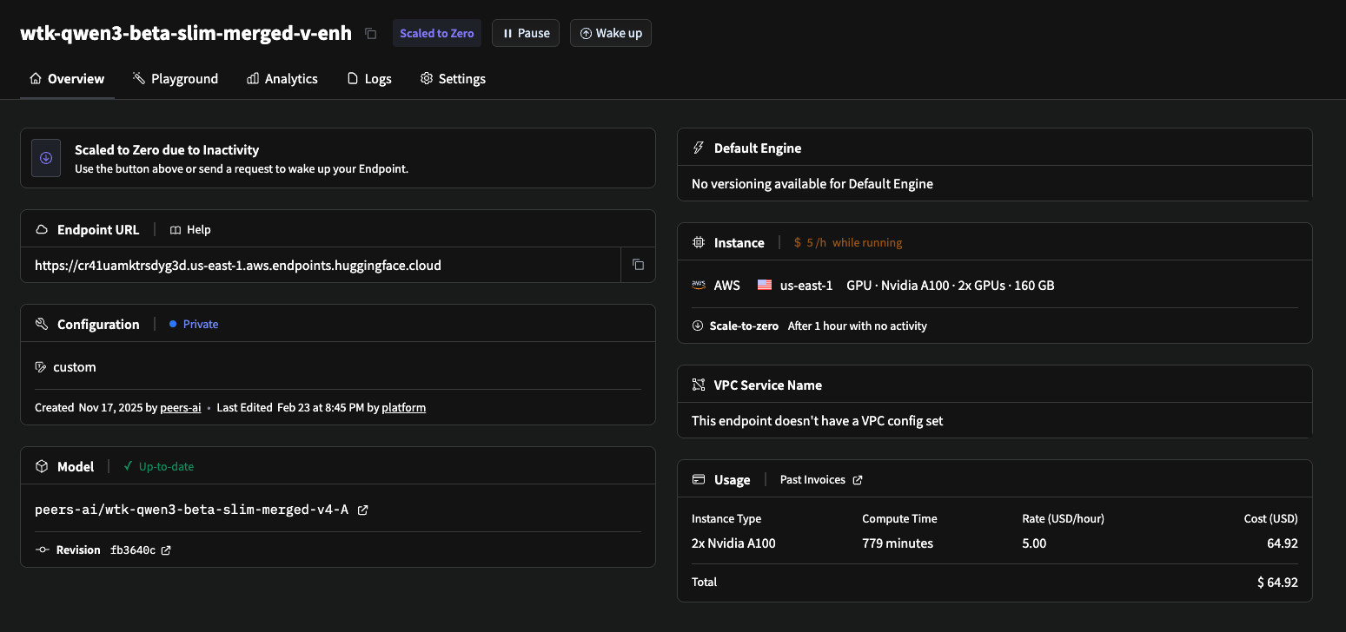

There are a number of important operations which you will commonly do.

How to wake up an instance

When the instance is asleep, click the “Wake up” button to start it.
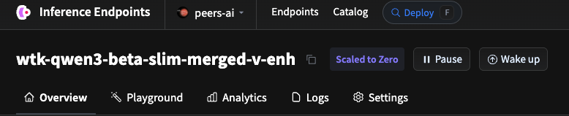

The instance status will say “Initializing” when it is starting up. It will take a few minutes to start up. When ready it will look like the below.
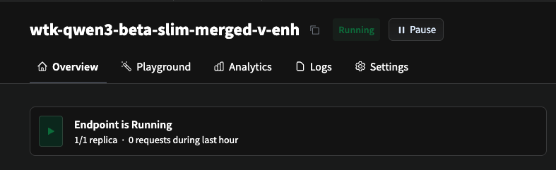

How to shutdown a running instance

To shutdown an instance when it is running, click Settings entry on the menu. The settings menu should appear.
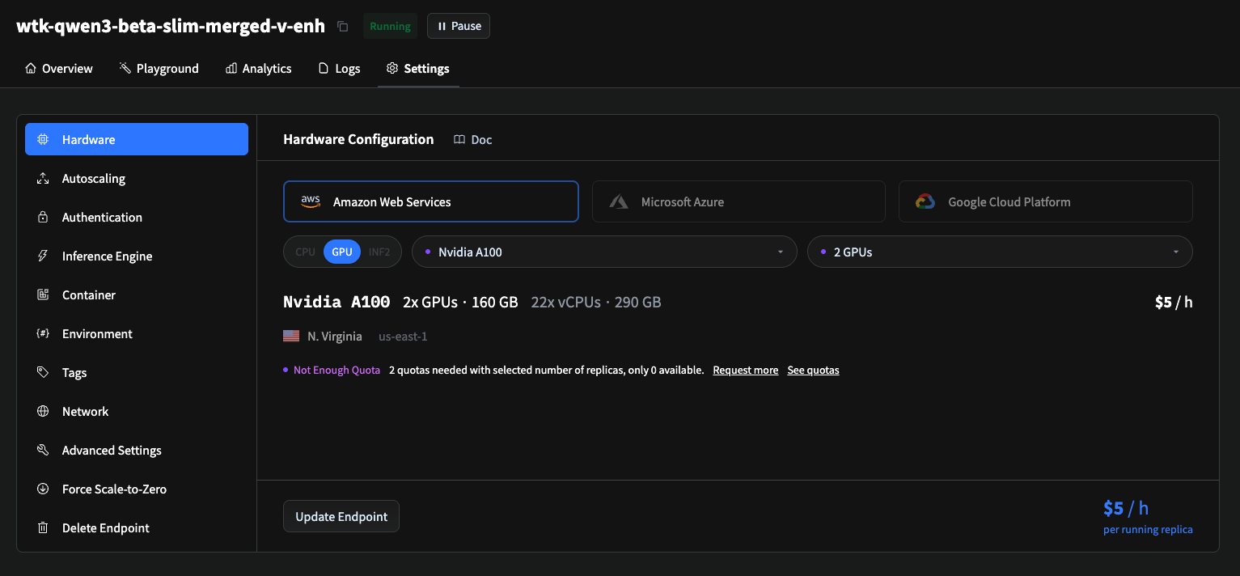

Then you want to find the “Force Scale-to-Zero” button. Then you will get the submenu.

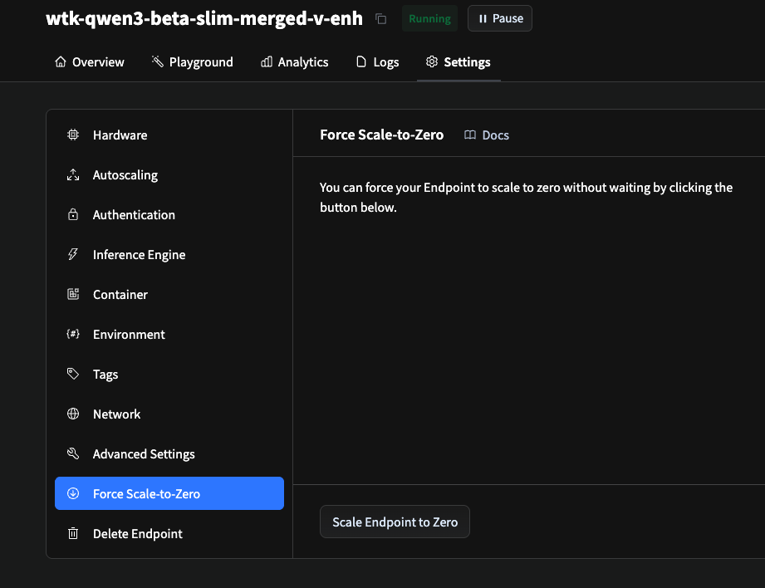

Click the “Scale Endpoints to Zero” button. The status should change to “Scaled to Zero.”

How to pause an instance


Pausing an instance stops the instance and makes it such that incoming queries do not wake up the instance.

Click the Pause button and then another pop-up comes up.

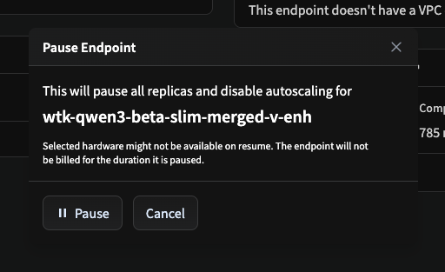

Click the Pause button on the pop-up.

The endpoint will now be paused and will not wake up on request until you press the Resume button.
